Willow Westbrook
Suffolk University
Undergraduate Research Project
What are cardiac implants:
In 1960, the first electronic pacemaker was invented by John Hopps (Current Market Insights, 2022), the device resembled a small radio, it measured 30 centimeters in length and used vacuum tubes to generate pulses. Hopps then created transvenous catheter electrodes which could be passed through the external jugular vein and eliminate the need to open a patient’s chest for heart stimulation. The same catheter electrodes that were used in the first version of the pacemaker are still used in today’s modernized implantable versions (BC Medical Journal, 2017).
Cardiac implants are implantable medical devices that monitor the arrhythmias in patients who suffer from heart disorders such as heart failure, ventricular tachycardia, ventricular fibrillation, and various others. These have become the cornerstone of management for patients with heart disorders over the decades, rhythm management devices may also improve the life expectancy and quality of life for patients. The objective of a cardiovascular implant is to assist in relieving a slow and/or irregular rhythm for a patient. Impressive progress in the field of cardiac implants has led to technical improvements in existing devices and leads, and new versions are constantly emerging. Increasing development of new cardiac implants and increasing engagement of business development strategies, such as collaboration between key market players, are expected to also aid market growth (Coherent Market Insights, 2022). The market is expected to witness significant growth over the next decade, bowing to the increasing focus of market players on technological innovations in the field of cardiac implantable devices.

What the market currently looks like:
The global cardiac implants market was estimated to be valued at US$ 35,795.6 million in 2022, the market is expected to show a compound annual growth period of 8.1% from 2022-2030 (Coherent Market Insights, 2022). Increasing risk of cardiovascular disease due to changes in lifestyle and dietary habits is expected to drive market growth, as well as technological innovations in the field of cardiac implants are expected to display remarkable growth over the next decade.
The cardiac market is segmented by product (Implantable Cardioverter-Defibrillators (ICDs), pacemakers, coronary stents, implantable heart rhythm monitors, implantable hemodynamic monitors, etc.), its application (arrhythmias, acute myocardial infarction, myocardial ischemia, and other applications…), its end-user (hospitals, cardiology centers, etc.), and geography (Europe, America, Asia-Pacific, Middle East, and Africa) (Modor Intelligence, 2023). The coronary stents segment is expected to hold a major market share over the next decade in the device type segment.
Growing cases of heart failure and the increasing frequency of cardiovascular diseases represent one of the key factors that are directly influencing the demand for cardiac implants worldwide. Inactive lifestyles, unhealthy dietary patterns, elevated stress levels, diabetes, and obesity are also big contributors to the demanding market. There is also an increase in preferences for minimally invasive surgeries due to their associated benefits. Integration of AI, predictive analytics, and advanced algorithms has aided in the early detection of heart disease.
The global market is segmented based on the regions: Europe, America, Asia-Pacific, Middle East, and Africa. North America is expected to hold the largest market share for its high adoption rates of cardiac implant devices, and an increase in prevalent cardiac diseases. In Europe, the global market is growing for factors like increasing the government’s healthcare sector funds and increasing the number of initiatives for cardiac patients by insurance companies (Gotadki, 2019).
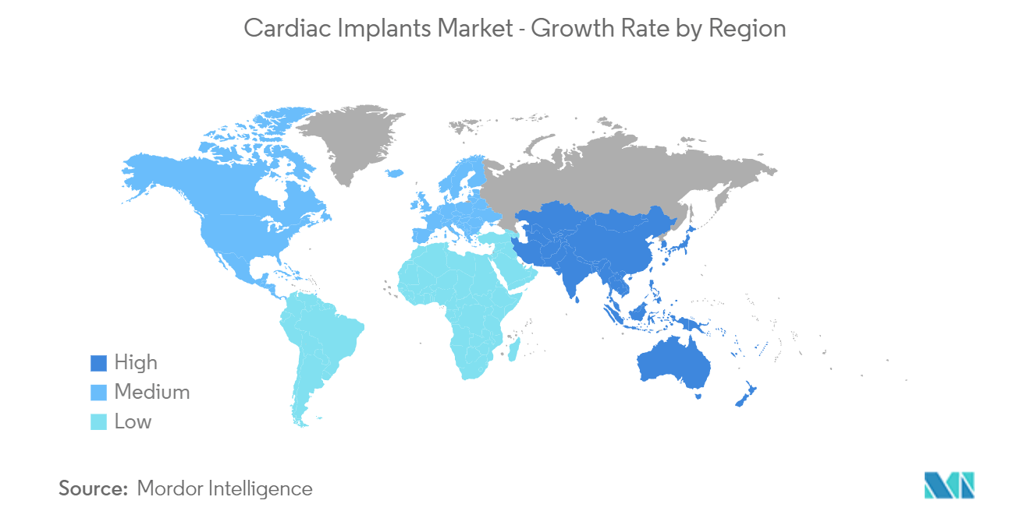
(Cardiac Implants Market Size & Share Analysis - Industry Research Report - Growth Trends. (n.d.). Www.mordorintelligence.com. Retrieved May 3, 2023, from https://www.mordorintelligence.com/industry-reports/cardiac-implants)
‌ Key players who are currently operating in the global cardiac implant market are Boston Scientific Corporation, Stryker Corporation, Biotronik, Medtronic, and Asahi Kasei Corporation. The key strategies followed by market players are product development, innovation, acquisition, and expansion. One of the leading companies, Medtronic, launched an advanced technology Implantable Cardioverter-Defibrillator (ICD) device that allows patients to gather information by holding an antenna over the implanted cardiac device (Gotadki, 2019).
Despite new developments, cardiac implants may have a downside associated with complications that come with using medical devices. Restraints of the global cardiac implant market are the increasing product recalls and cardiac implant-related infections. Short-circuiting is another problem that medical device companies face, this decreases battery life which results in devices producing a warning that the battery is low, earlier than expected. Many complications are related to the transvenous lead and the subcutaneous pocket. The transvenous leads can cause dislocation, mechanical damage, tricuspid regurgitation, venous occlusion, superior vena cava syndrome, cardiac perforation, and.

Insight of the Market over the Next Decade
Generally, the older population is more susceptible to diseases as with aging, the heart and blood vessels become stiff which can lead to conditions such as heart disease, coronary artery disease, and more. Increasing the awareness of different types of medical implants among healthcare professionals can boost the growth of the cardiac implant industry, introducing new advanced technologies in medical implants, availability of better medical facilities, and cases with damaged organs due to different accidents are opportunities to increase the cardiac implants market share as well.
Progression of Analytics Involved
Build of a Cardiac Implant
Market Players and Their Market Position
Business Position
Analytical Position
Outlook on the Analytical Side over the Next Decade
Conclusion

